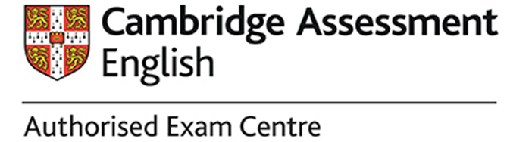

Dear candidates,

Due to the COVID-19 crisis, a number of extraordinary rules and conditions apply in order to protect your health and safety. Any failure to comply with these rules, or quarrel with any member of the exam day staff, will be treated as malpractice and lead to disqualification. For that reason, please pay close attention to the following points:
- You are not allowed to appear at the venue or take part in the exam if:
  - you have returned from abroad within the last 14 days;
  - you are in domestic quarantine;
  - you have acute signs of a cold (such as fever, cough, shortness of breath, muscle or joint pain, sore throat, headache, cold, diarrhea);
  - a Covid-19 case has occurred in your immediate contact area (family environment);
  - you belong to a risk group due to a previous illness or a family member belongs to a risk group due to a previous illness and it is not possible to conduct the examination in isolation from other students.
An elevated body temperature, i.e. a temperature higher than 37.5 degrees without any other symptoms, is also a reason for not participating in the examination. In all the above-mentioned cases, stay at home and call in sick with an appropriate note.
- If you display any sign of illness or a high temperature when you arrive at the centre, you will be asked to leave the premises immediately.
- Should you be unable to attend the examination due to illness, we can transfer your registration to later date or offer you a refund.
- You must bring your own face mask and wear this when you arrive and register at the centre, during the breaks between papers, and when you leave. You are also welcome to wear a mask during the written and speaking tests. You should also bring a packet of tissues as these will not be provided.
- Please also note that we will regularly open the windows for ventilation. Depending on the weather, they may even stay open all the time. So please dress warm enough or bring a vest etc. with you, which you can put on if necessary.
- At the entrance to the building, the invigilators will make sure that candidates enter the building individually and at a distance.
- Protect yourself and others by keeping a distance (at least 1.5m - 2m) to other candidates and supervisors. Talking together in groups is prohibited at all times.
- You are welcome to bring along smaller packages of disinfectants for your own use and to wear (disposable) gloves.
- The doors in the building will be open so that you can enter your examination room directly without touching anything. As soon as you do, you will be asked to visit the bathroom to wash your hands.
Before registering with the supervisor, please take out your identity card, and mobile phone. You must place all electronic devices in a plastic bag which will be stored securely until the end of the listening test. We cannnot accept any responsibility for these devices, however. Then disinfect your hands and enter the examination room, where you will be told where to sit by the exam staff.
- On your desk you may keep: a pen; pencil; eraser; pencil sharpener; your ID; and water in a clear plastic bottle. Leave everything else at the back of the room, then quickly sit down.
- Once a test has started you will not be allowed to ask any questions about the content at specified times.
- Please keep toilet visits to a minimum, you will not be given extra time if you visit the toilet once a test has started. Make sure you keep your distance from others and wash your hands thoroughly (for at least 30 seconds).
- Toilet visits are only possible at certain times and individually. When using the toilet, please take special care to touch only the bare essentials and leave everything clean. After thoroughly washing your hands, always use disinfectant.
- If you finish early, you can leave the exam room any time after thirty minutes from the start of the test and ten minutes before the end of a test.
- Ten minutes before the end of a test, you must remain in your seat and remain silent until you are told that you can leave.
- When you have finished your tests, please close all of your papers and leave them on your table. Do not take any materials out of the room.
- During the breaks do not speak to other candidates and do not stand in groups.
- After the written papers you will need to leave the premises until you return to register twenty minutes before the starting time of your speaking test.
- On the day of your exam it may become necessary to give you additional rules. You must also adhere to these rules.

